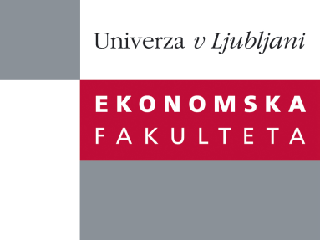

Raziskovalni center Ekonomske fakultete
organizira znanstveno - raziskovalni seminar,
ki bo v četrtek, 12. Decembra 2013, ob 13:00 uri
v P-109 na Ekonomski fakulteti v Ljubljani.

Predstavljen bo članek:

“Creative Industries and Creative Index: Towards Measuring the "Creative" Regional Performance”

avtor: Pavel Bednář in Lukáš Danko, Univerza Zlin, Češka

˝Czech society does not predominantly consider the level of culture as a dominant factor for economic development. Moreover, it is considered as superstructure according to Marxist theory. Thus, inherited “communistic” perception of culture, associated with the influence of the former Soviet Union, is bearing emphasis on folk culture, “high art” professional scene, cultural heritage, and independent production vice versa. However, the importance of creative industries is being discovered in the last decade. The first aim of this paper is to reveal and explain disparities within creative industries and the New Creative Index in Czech regions employing multidimensional scaling to evaluate the concept of smart specialization. Furthermore, it is focused on modelling the links between the New Creative Index and creative circles using correlation to measure the "Creative" Regional Performance. The West–East gradient, previous development trajectories and the structure of higher education in Czech regions lead to an increasing divergence, even the support of all cultural activities was declared. The results presented in this paper reflect the link of the structural base support, related to the concept of clustering and regional development of certain creative industries in particular regions. This leads into the specialised regional support of selected creative industries according to the NCI and the structure of creative industries. Thus, it is supposed that regional cultural or cluster policy shall employ various tools in terms of priorities and provide support to fulfil the concept of smart specialization.˝

Na brezplačni seminar se lahko prijavite v Službi za znanstveno raziskovalno delo, po telefonu (01) 58-92-490, ali po e-pošti research.seminars@ef.uni-lj.si, in sicer do srede, 11.12.2013.

Vljudno vabljeni!

