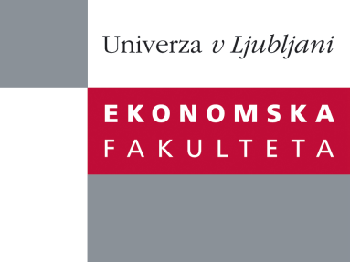

Raziskovalni center Ekonomske fakultete
organizira znanstveno - raziskovalni seminar,
ki bo v sredo, 11. Decembra 2013, ob 12:00 uri
v P-109 na Ekonomski fakulteti v Ljubljani.

Predstavljen bo članek:

“ METAPHORS IN CONTEMPORARY ECONOMIC AND MANAGERIAL DISCOURSE”

avtor: dr. Bratož Silva, Univerza na Primorskem

˝Metaphors may provide valuable insights into how economic processes and participants involved in them are conceptualised. The present paper focuses on conceptual metaphors found in English and Slovene contemporary economic and managerial discourse. The methodological framework is related to the cognitive linguistic view of metaphor according to which metaphors are a fundamental component of human cognition and a means of conceptualising more abstract areas of our experience in terms of familiar and concrete. On this account, the study of metaphor is today seen as inevitably interdisciplinary in nature, with authors in economic and management studies, for example, relating to the work of linguists and psychologists and vice versa. Several examples of conceptual metaphors and their linguistic realisations will be discussed from a cross-cultural and cross-linguistic perspective, such as the metaphorical conceptualisations of the economy as a ship and managers as ship’s captains and others. In addition, it will be argued that certain metaphorical concepts are deeply embedded in our minds, often reflecting important ideological implications.˝

Na brezplačni seminar se lahko prijavite v Službi za znanstveno raziskovalno delo, po telefonu (01) 58-92-490, ali po e-pošti research.seminars@ef.uni-lj.si, in sicer do torka, 10.12.2013.

Vljudno vabljeni!

