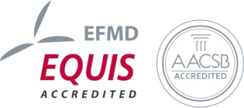
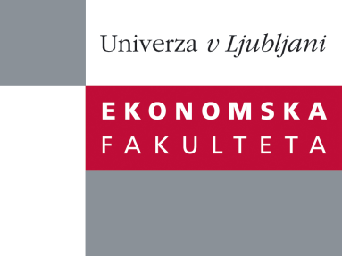

Raziskovalni center Ekonomske fakultete
organizira znanstveno - raziskovalni seminar,
ki bo v sredo, 13. Novembra 2013, ob 13:00 uri
v P-109 na Ekonomski fakulteti v Ljubljani.

Predstavljen bo članek:

“Researching brand opportunities from a typology of Facebook fans”

avtor: Professor Leslie de Chernatony, Aston Business School, Birmingham, UK

˝In the literature there is a lot about the increasing number of “Likes” on Facebook but little has been written about why consumers become brand fans on Facebook. Not all fans are created equal. Furthermore little is known about the relationship between Facebook fans and their “Liked” brands.
This seminar will provide an exploratory insight to a typology based on brand loyalty, brand love, WOM and use of self-expressive brands.˝

Na brezplačni seminar se lahko prijavite v Službi za znanstveno raziskovalno delo, po telefonu (01) 58-92-490, ali po e-pošti research.seminars@ef.uni-lj.si, in sicer do torka, 12.11.2013.

Vljudno vabljeni!

