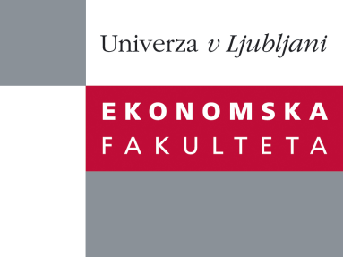

Raziskovalni center Ekonomske fakultete
organizira znanstveno - raziskovalni seminar,
ki bo v sredo, 9. oktobra 2013, ob 12:00 uri
v P-109 na Ekonomski fakulteti v Ljubljani.

Predstavljen bo članek:

“HORIZONTAL MISMATCH IN THE LABOUR MARKET OF GRADUATES: THE ROLE OF SIGNALLING”

avtorji: dr. Farčnik Daša, Ekonomska fakulteta, prof. dr. Domadenik Polona, Ekonomska fakulteta, dr. Francesco Pastore, Seconda Università di Napoli and IZA of Bonn

˝We follow Brodaty et al. (2008) and develop a model within the signalling literature where an employer decides whether to hire a worker or not conditionally on the signals she sends – field and length of study and high education (HE) institution. The empirical design of our paper builds on evidence relative to first labour market entry of graduates to identify a signalling effect of individual and institutional quality of study on individual horizontal match quality.
First, based on a matched unique employer-employee dataset we report the extent of horizontal mismatch for graduates of different fields of education for a post-transition economy (Slovenia). Second, we test the signal of HE institutions and above average study duration on the likelihood of a horizontal mismatch separately for each field of education. We find that graduates from specific HE institutions experience significantly higher likelihood to get a job that matches the field of study for social sciences, namely business and administration and to a smaller extent education. On the contrary, HE institutions do not signal skills or abilities in the most technical fields of education (engineering, computing, manufacturing). The above average study duration has mixed effects based on the field of education. It can either signal lower innate ability (i.e. for law graduates) or increased skills due to student work (i.e. computing graduates).˝

Na brezplačni seminar se lahko prijavite v Službi za znanstveno raziskovalno delo, po telefonu (01) 58-92-490, ali po e-pošti research.seminars@ef.uni-lj.si, in sicer do torka, 8.10.2013.
Vljudno vabljeni!

