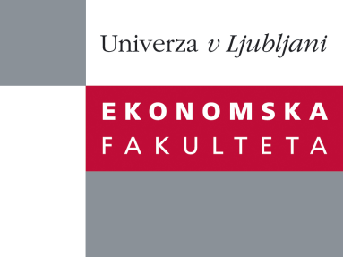

Raziskovalni center Ekonomske fakultete
organizira znanstveno - raziskovalni seminar,
ki bo v sredo, 4. Decembra 2013, ob 12:00 uri
v P-109 na Ekonomski fakulteti v Ljubljani.

Predstavljen bo članek:

“Debt Financing and Firm Performance before and during the Crisis: Micro-Financial Evidence from Slovenia”

avtor: Uroš Herman, Banka Slovenije (soavtoji: Mateja Gabrijelčič, Banka Slovenije in Andreja Lenarčič, Banka Slovenije)

˝This paper studies the effects of different financing possibilities on performance of firms before and during the recent crisis, using a large panel of Slovenian companies for the period between 2001 and 2011. We find a significant negative effect of leverage on firm performance. The estimated negative effect is stronger in the pre-crisis period, when taking into account the reverse causality between financial leverage and firm performance. In addition, we find that firms that had some foreign debt financing performed better than their counterparts. At the same time, the presence of foreign debt amplifies the negative effect of total leverage on firm performance. These findings remain largely unchanged when looking at subsamples with domestic and foreign firms only.˝

Na brezplačni seminar se lahko prijavite v Službi za znanstveno raziskovalno delo, po telefonu (01) 58-92-490, ali po e-pošti research.seminars@ef.uni-lj.si, in sicer do torka, 3.12.2013.
Vljudno vabljeni!

