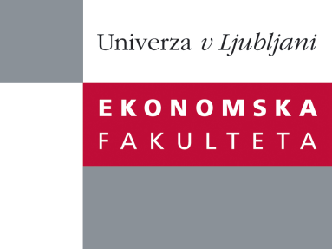

Raziskovalni center Ekonomske fakultete
organizira znanstveno - raziskovalni seminar,
ki bo v sredo, 18. Decembra 2013, ob 12:00 uri
v P-109 na Ekonomski fakulteti v Ljubljani.

Predstavljen bo članek:

“Clustering data described with discrete distributions: presentation of a clustering method with a case study on population pyramids”

avtor: doc. dr. Korenjak Černe Simona, (soavtorja:prof. dr. Batagelj Vladimir in prof. dr. Nataša Kejžar)vsi iz Univerze v Ljubljani

˝Classical clustering approaches are based on classical data descriptions with single-value vectors. Therefore in the case of population pyramids, only the shapes can be compared, since real population sizes and distributions are not properly considered in these data descriptions. We adapted well-known k-means and Ward’s hierarchical clustering methods for clustering units where variables are described with discrete distributions. Both methods are compatible (they are solving the same clustering optimization problem) and therefore can be used in combination. The implementation was done in R. Properties and advantages of such an adaptation will be presented.˝

Na brezplačni seminar se lahko prijavite v Službi za znanstveno raziskovalno delo, po telefonu (01) 58-92-490, ali po e-pošti research.seminars@ef.uni-lj.si, in sicer do torka, 17.12.2013.
Vljudno vabljeni!

