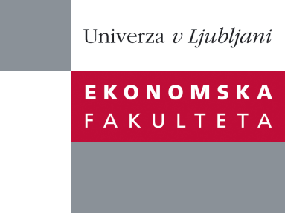

Raziskovalni center Ekonomske fakultete
organizira znanstveno - raziskovalni seminar,
ki bo v četrtek, 19. Decembra 2013, ob 13:00 uri
v P-109 na Ekonomski fakulteti v Ljubljani.

Predstavljen bo članek:

“Integrated performance management systems: Jack of all trades and master of none?”

avtor: doc. dr. Peljhan Darja in doc. dr. Marc Mojca, Univerza v Ljubljani

˝Performance management (PM) tools have evolved from those focused on better costing (e.g. activity based costing) or better process management (e.g. total quality management) to more comprehensive approaches known as ‘integrated’ performance management systems (IPMS; e.g. balanced scorecard). Many companies have implemented more than just one type of PM tool. Despite several cases of successful PM tools implementation, there is a continuous debate on the possible implementation problems preventing PM tools to succeed in improving organizational performance. However, existing literature does not provide an answer to the following dilemmas: i) whether additional PM tool implementation contributes to the existing tools and ii) whether PM tools are acting as substitutes or as complementary tools. Therefore, the aim of our study is to comprehensively investigate the relationship among different types of PM tools and to identify their direct and indirect effects on the perceived importance of different performance measures (traditional and non-traditional). Based on the literature review we develop hypotheses and estimate a structural equation model on cross-sectional survey data. Our results show that companies using cost or process related PM tools are more likely to use also IPMS. However, companies with cost related PM tools can benefit more from implementing IPMS than companies with process related PM tools. Despite the fact that IPMS do contribute to higher perceived importance of most performance perspectives, their incremental contribution is relatively small. Even more, our results show that IPMS do not increase the perceived importance of all non-traditional performance perspectives. IPMS seem to increase the perceived importance of employee and productivity perspectives, but not of operational and customer perspectives. This unexpected finding puts under question the inherent ‘balancing role’ of IPMS and has potentially powerful implications for management control practice.˝

Na brezplačni seminar se lahko prijavite v Službi za znanstveno raziskovalno delo, po telefonu (01) 58-92-490, ali po e-pošti research.seminars@ef.uni-lj.si, in sicer do srede, 18.12.2013.
Vljudno vabljeni!

