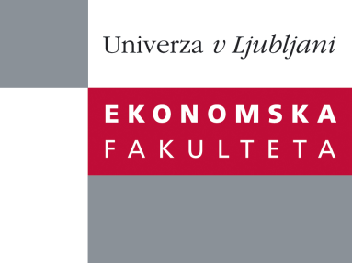

Raziskovalni center Ekonomske fakultete
organizira znanstveno - raziskovalni seminar,
ki bo v petek, 6. Decembra 2013, ob 11:00 uri
v P-108 na Ekonomski fakulteti v Ljubljani.

Predstavljen bo članek:

“Designing Organizations for Large-Scale, Multi-Party Collaboration”

avtor: prof. Charles Snow, The Pennsylvania State University in University of Melbourne (soavtorji: Øystein D. Fjeldstad, BI-Norwegian Business School, Raymond E. Miles, University of California in Christopher Lettl, Vienna University)

˝Knowledge-intensive industries like computers, biotechnology, and microelectronics are the spawning ground for emerging organizational forms. In such industries, the knowledge base needed to develop new products, services, and technologies is complex, growing, and widely diffused. New organizational approaches enable various parties to collaborate with one another both to add to and exploit relevant knowledge. Traditional hierarchical organizations are not particularly well suited to multi-party collaboration. New organization designs based on an "actor-oriented" architectural scheme are required in knowledge-intensive sectors. This seminar discusses the core elements of the actor-oriented scheme.˝

Na brezplačni seminar se lahko prijavite v Službi za znanstveno raziskovalno delo, po telefonu (01) 58-92-490, ali po e-pošti research.seminars@ef.uni-lj.si, in sicer do četrtka, 5.12.2013.

Vljudno vabljeni!

