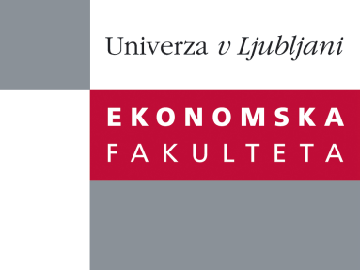

Raziskovalni center Ekonomske fakultete
organizira znanstveno - raziskovalni seminar,
ki bo v sredo, 20. Novembra 2013, ob 14:00 uri
v P-213 na Ekonomski fakulteti v Ljubljani.

Predstavljen bo članek:

“Inflation Dynamics During the Financial Crisis”

avtorji: Egon Zakrajšek, Federal Reserve Board, Simon Gilchrist, Boston University, Raphael Schoenle, Brandeis University, Jae W. Sim, Federal Reserve Board

“Using confidential product-level price data underlying the U.S. producer Price Index (PPI), this paper analyses the effect of changes in firms’ financial conditions on their price-setting behaviour during the “Great Recession” that surrounds the financial crisis. The evidence indicates that during the height of the crisis in late 2008, firms with “weak” balance sheets increased prices significantly relative to industry averages, whereas firms with “strong” balance sheets lowered prices, a response consistent with an adverse demand shock. These stark differences in price-setting behaviour are consistent with the notion that financial frictions may significantly influence the response of aggregate inflaction to macroeconomic shocks. We explore the implications of these empirical findings within a general equilibrium framework that allows for customer markets and departures from frictionless financial markets. In the model, firms have an incentive to set a low price to invest in market share, though when financial distortions are severe, firms forgo these investment opportunities and maintain high prices in an effort to preserve their balance-sheet capacity. Consistent with our empirical findings, the model with financial distortions- relative to the baseline model without such distortions- implies a substantial attenuation of price dynamics in response to contractionary demand shocks.”

Na brezplačni seminar se lahko prijavite v Službi za znanstveno raziskovalno delo, po telefonu (01) 58-92-490, ali po e-pošti research.seminars@ef.uni-lj.si, in sicer do torka, 19.11.2013.
Vljudno vabljeni!

