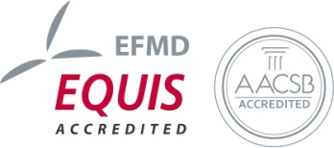
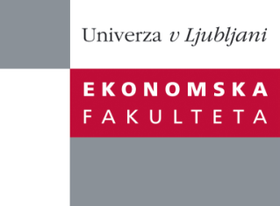

Raziskovalni center Ekonomske fakultete
organizira znanstveno-raziskovalni seminar,
ki bo v četrtek, 24. januarja 2013, ob12:00 uri
v P-109na Ekonomski fakulteti v Ljubljani.

Predstavljen bo članek:

“Trade vs. Bank Credit Substitution– The SMEs financing dynamic in an Economic Crisis"

Avtorica: dr. Barbara Mörec (soavtor: dr. Matevž Rašković, Ekonomska fakulteta, Univerza v Ljubljani)

“Our paper explores the existence of the substitution effect between trade and bank credit and shows how this effect is stronger in the initial phase of the economic crisis and among SMEs. For the period of 2007-2010 we examine the determinants of trade credit use among SMEs in a series of cross-section robust regression, and fixed effects panel regression models on a sample of SMEs (including micro companies) in Slovenia, country where access to financing is the most problematic factor for conducting business according to World Economic Forum GCI (2012-2013). We demonstrate how the counter-cyclical substitution effect between trade and bank credit does not only differ across the various phases of the current global economic crisis, but also across different company size groups, where SMEs have actually become “double victims” of the crisis: not only is it harder than ever for SMEs to access a bank loan, but also large companies are no longer able to grant trade credit to their smaller suppliers.”

Na brezplačni seminar se lahko prijavite v Službi za znanstveno raziskovalno delo, po telefonu (01) 58-92-490 ali po e-pošti research.seminars@ef.uni-lj.si, do srede, 23.01.2013.
Vljudno vabljeni!

