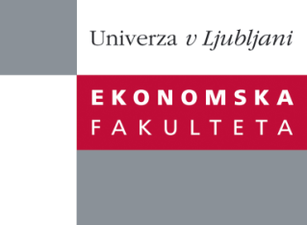
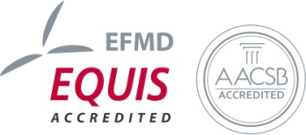

The ResearchCentre of the Faculty of Economics
cordially invites you to a research seminar
on Wednesday, 1st July 2015 at 12 p.m. in room P-109 at the
Faculty of Economics, University of Ljubljana

Author: Matej Švigelj, PhD, University of Ljubljana, Faculty of Economics
Coauthor: Nevenka Hrovatin, PhD, FELU
Coauthor: Jelena Zorić, PhD, FELU

will present the article:

"What drives Internet users to subscribe to new generation access networks and higher Internet speeds?"

“This paper investigates the determinants of consumers’ willingness to pay (WTP) for next-generation access (NGA) in Slovenia. The WTP for NGA is estimated in two ways. First, following the EU Digital Agenda target whereby all households should have Internet access of at least 30 Mbps by 2020, the WTP for an Internet speed of 30 Mbps is analysed. Second, the WTP for FTTH, which is the most advanced form of NGA networks, is also examined. The results show that the quality of Internet services, the presence of a student or pupil in the household and employment status play an important role in explaining both WTP decisions. The results of our analysis may help Internet service providers design new or adjust existing broadband packages to foster migration to NGA networks and high-speed broadband. They could also help policy-makers identify remedies which could reduce the demand gap for NGA networks.”

You can register for the free seminar by phone (01) 58-92-490, or via e-mail: research.seminars@ef.uni-lj.si by Tuesday, 30th June 2015.

We look forward to seeing you!

