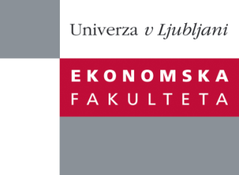
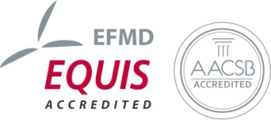

The Research Centre of the Faculty of Economics
cordially invites you to a research seminar
on Thursday, 2nd July 2015 at 12 p.m. in room P-109 at the
Faculty of Economics, University of Ljubljana

Author: Miroslav Verbič, PhD, University of Ljubljana, Faculty of Economics
will present the article:

"An Analysis of Adopting Dual Pricing for Museums: The Case of the National Museum of Iran"

“The paper analyzes the admission fees that foreign and domestic visitors are willing to pay, respectively, for the National Museum of Iran, and examines the relationship between the visitors’ willingness-to-pay and their various socio-economic, geographical, and psychological characteristics. It was established that the two segments of visitors differ substantially, both in their characteristics and in their behavior. Unlike for domestic visitors, the entrance fees that foreign visitors are willing to pay are substantially higher than the current single entrance fee, while higher entrance fees would not decrease the consumer surplus significantly. The findings, if applied with caution, could provide museum managers with the rationale for adopting dual pricing and with practical directions for setting such schemes.”

You can register for the free seminar by phone(01) 58-92-490, or via e-mail: research.seminars@ef.uni-lj.si by Wednesday, 1st July 2015.

We look forward to seeing you!

