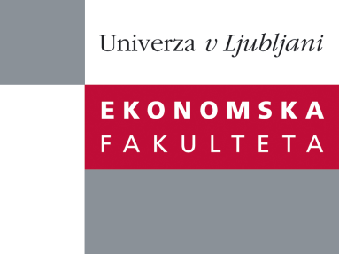

Raziskovalni center Ekonomske fakultete
organizira znanstveno - raziskovalni seminar,
ki bo v sredo, 25. septembra 2013, ob 13:00 uri
v P-109 na Ekonomski fakulteti v Ljubljani.

Predstavljen bo članek:

“WHAT CAN BE LEARNED FROM ENTREPRENEURS ABOUT SHADOW ECONOMY?
Evidence from the Baltic States.”

avtor: Arnis Sauke, Ph.D, Stockholm School of Economics in Riga, Tālis J. Putniņš, Ph.D, Stockholm School of Economics in Riga

˝This study develops a method that uses entrepreneurs to measure the size of a shadow economy. Using the premise that entrepreneurs themselves are most likely to know how much business income and wages go unreported, our estimates are derived from surveys of entrepreneurs. We use a range of survey design features to maximise the truthfulness of responses. Our method combines estimates of misreported business income, unregistered or hidden employees, and unreported wages, to arrive at an estimate of the size of a shadow economy as a percentage of GDP. This approach differs from most other studies of shadow economies, which largely focus on using macro indicators. We illustrate the application of our method to three new EU member countries. We also analyse the factors that influence entrepreneurs’ participation in the shadow sector and use our shadow economy estimates to correct official GDP measurements.˝

Na brezplačni seminar se lahko prijavite v Službi za znanstveno raziskovalno delo, po telefonu (01) 58-92-490, ali po e-pošti research.seminars@ef.uni-lj.si, in sicer do torka, 24.09.2013.
Vljudno vabljeni!

