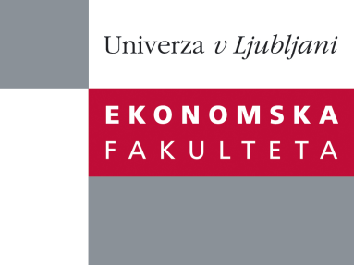

Raziskovalni center Ekonomske fakultete
organizira znanstveno - raziskovalni seminar,
ki bo v sredo, 16. Oktober 2013, ob 12:00 uri
v P-109 na Ekonomski fakulteti v Ljubljani.

Predstavljen bo članek:

“Cultural Fitness for BPM”

avtor: doc. dr. Theresa Schmiedel iz University of Liechtenstein

"Cultural resistances are widely acknowledged as a key reason for failure of BPM initiatives. While many practitioners agree that organizational culture plays an important role in BPM, most BPM projects do not consider the values that are shared by the people executing the processes. This talk provides insights into the cultural values that are required for BPM success. It will be shown how these values can be measured to determine the current cultural fitness of an organization for BPM and to derive culture development strategies for the future”

Theresa Schmiedel is Assistant Professor at the Institute of Information Systems of the University of Liechtenstein. She holds a PhD in business economics from the University of Liechtenstein and a Diploma in economics from the University of Hohenheim, Stuttgart, Germany, which she conducted partially at York University, Toronto, Canada. She worked as a Research Assistant at the Department for Sociology and Empirical Social Research, University of Hohenheim, and at the Centre for Cultural and General Studies, Universität Karlsruhe, Germany. Her research focuses on social aspects in information systems research, particularly on the interconnection of culture and business process management. Her work has been published in the Business Process Management Journal, respective books and academic conferences. You can contact her at theresa.schmiedel@uni.li.

Na brezplačni seminar se lahko prijavite v Službi za znanstveno raziskovalno delo, po telefonu (01) 58-92-490, ali po e-pošti research.seminars@ef.uni-lj.si, in sicer do torka, 15.10.2013.
Vljudno vabljeni!

