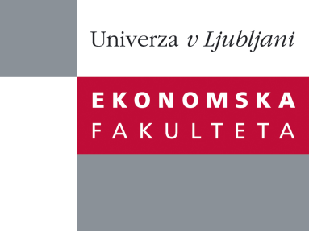

Raziskovalni center Ekonomske fakultete
organizira znanstveno - raziskovalni seminar,
ki bo v sredo, 6. Novembra 2013, ob 12:00 uri
v P-109 na Ekonomski fakulteti v Ljubljani.

Predstavljen bo članek:

“Earnings Inequality and Tax Progressivity in Slovenia, 1991–2009”

avtorja: doc. dr. Verbič Miroslav, Ekonomska fakulteta in prof. dr. Stanovnik Tine, Ekonomska fakulteta

˝The article analyses the distribution of employee earnings in Slovenia in the period 1991–2009. The analysis is based on large samples from the personal income tax (PIT) files. Using the Gini coefficient as the indicator of income inequality, increases in earnings inequality were moderate; however, relatively large increases in the shares accruing to the top 5% and top 1% of employees did occur. Inequality of employees’ after-tax earnings (i.e. net of employee social contributions and PIT) remained fairly stable in this time period, due to the increasing progressivity of the PIT, as shown by the Kakwani index of progressivity. Increases in progressivity of the personal income tax came in leaps, following the passage of new income tax legislation. Institutional settings and the introduction of minimum wage legislation in 1995 also appear to have moderated inequality increases, which were quite large in the early years of transition.˝

Na brezplačni seminar se lahko prijavite v Službi za znanstveno raziskovalno delo, po telefonu (01) 58-92-490, ali po e-pošti research.seminars@ef.uni-lj.si, in sicer do torka, 5.11.2013.

Vljudno vabljeni!

