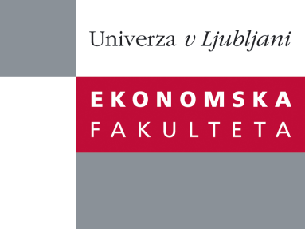

Raziskovalni center Ekonomske fakultete
organizira znanstveno - raziskovalni seminar,
ki bo v sredo, 10. Julija 2013, ob 12:00 uri
v P-109 na Ekonomski fakulteti v Ljubljani.

Predstavljen bo članek:

“Impact of energy policy instruments on the estimated level of underlying energy efficiency in the EU residential sector ”

avtor: doc. dr. Jelena Zorić, Ekonomska fakulteta (soavtorji: prof. dr. Massimo Filippini, University of Lugano, Switzerland and prof. dr. Lester C. Hunt, University of Surrey, UK)

The promotion of energy efficiency is seen as one of the top priorities of EU energy policy (EC, 2010). In order to design and implement effective energy policy instruments, it is necessary to have information on energy demand price and income elasticities in addition to sound indicators of energy efficiency. Following Filippini and Hunt (2011, 2012) this research combines the approaches taken in energy demand modelling and stochastic frontier analysis (SFA) in order to estimate the level of inefficiency for the residential sector in the EU-27 member states for the period 1996 to 2009. This is argued to represent potential for energy efficiency improvement. As opposed to the more conventional indicator of energy intensity (i.e., energy demand to GDP ratio), this measure of energy efficiency controls for a range of economic and other factors and is therefore viewed as a more suitable approach to measure energy efficiency. Estimation results confirm that the EU residential sector indeed holds a relatively high potential for energy savings from reduced inefficiency. Furthermore, an attempt is made to evaluate the impact of energy-efficiency measures undertaken in the EU residential sector by introducing an additional set of variables into the model and the results suggest that financial incentives and energy performance standards play an important role in promoting energy efficiency improvements, whereas informative measures do not have a significant impact.

Na brezplačni seminar se lahko prijavite v Službi za znanstveno raziskovalno delo, po telefonu (01) 58-92-490, ali po e-pošti research.seminars@ef.uni-lj.si, in sicer do torka, 9.7.2013.
Vljudno vabljeni!

